**Saint Brigid Saint John the Baptist**

3th Sunday of Easter

April 15, 2018

**Catholic Church Catholic Church**

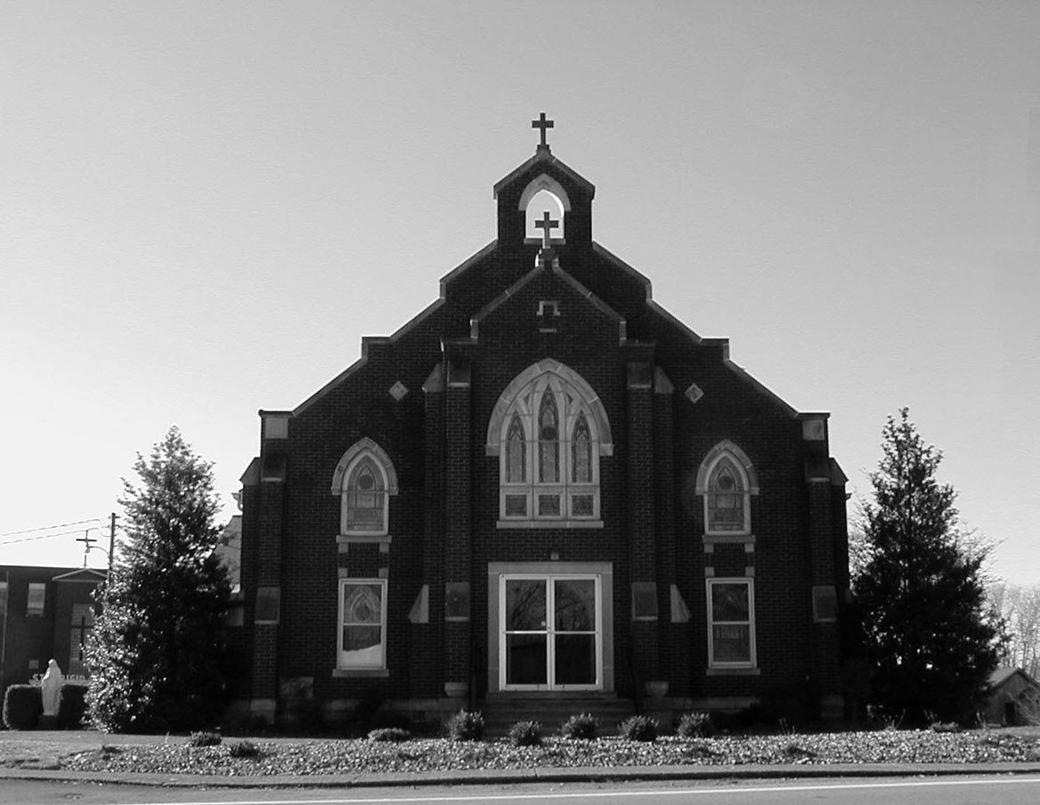

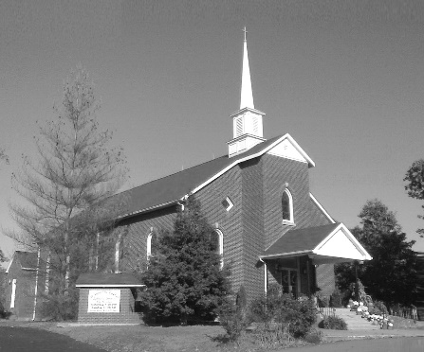

**Pastor:**

***Rev. Daniel L. Lincoln***

Rectory: (270) 877-2546

**Deacon:**

***Michael A. Ryan***

(270) 272-6789

314 E. Main St. 657 St. John Church Rd.

Vine Grove, KY 40175 Elizabethtown, KY 42701

Clustered Parish Office: Clustered Parish Office:

(270) 877-2461 (270) 877-2461

**ANNOINTING OF THE SICK:**

Notify the parish office when a family member is hospitalized.

**BAPTISM:**

Contact the parish office for information about the required preparation class.

**BULLETIN:**

Information must be submitted in writing by note or email to the parish office **no later than 12:00 noon on Wednesdays** for the following weekend. When sending an email, please put “BULLETIN,” and the name of the parish the announcement is for, in the subject line.

**MARRIAGE:**

Contact Father at least 6 months prior to the wedding date to complete required marriage preparations and to schedule the date.

**RCIA (Rite of Christian Initiation of Adults):**

Contact the Worship Chairperson for information.

**DEW MEMORIAL LIBRARY:**

(in St. Brigid Church basement):

Open: Sunday after 9:30 a.m. Mass& 45 minutes before all other Masses.

Email: [brigidvg@bbtel.com](mailto:brigidvg@bbtel.com)

Website:[www.stbrigidvg.org](http://www.stbrigidvg.org)

**Pastoral Associate & Dir. Dir. of Religious Education:**

**of Religious Education:** Lisa Thomas: (270) 735-6930

Deacon Mike Ryan: (270) 877-0546

**Youth Minister: Youth Ministers:**

Lori Law: (270) 723-0157 Angela Churchman:

(270) 268-9963

Ericka Finlay: (502) 612-2644

**MASS SCHEDULE:**

*Sunday:* 9:30 a.m. & 6:30 p.m.

*Monday:* 9:00 a.m.

*Thursday:* 9:00 a.m.

**RECONCILIATION:**

Sunday before Mass

5:30-6:00 p.m. or by appt.

**ROSARY:**

After weekday Masses

**PARISH COUNCIL MEMBERS:**

*President:* Sue Weisshaupt

*Vice-President:* Mike Bramlett

*Secretary:* Judy Cochran

*At-Large Members:* Blake Ryan

& Vincent Thompson

**CHAIRPERSONS:**

*Administration:* Dale Winchester

*Formation:* Tina Yates

*Parish Life:* Tom Billings

*Worship:* Keith Baughman

**MASS SCHEDULE:**

*Saturday (Vigil):*  6:30 p.m.

*Sunday:* 11:30 a.m.

*Wednesday:* 6:30 p.m.

*Friday:* 9:00 a.m.

**RECONCILIATION:**

Saturday before Mass

5:30-6:00p.m. or by appt.

**PARISH COUNCIL MEMBERS:**

*President:* Theresa Smith

*Secretary:* Karen Ray

**CHAIRPERSONS:**

*Administration:* Rick Newton

*Formation:* Ericka Newton

*Parish Life:* Bradley Wickersham

*Worship:* Nick Thomas



**Mass Schedule**

**Mass Schedule**

|  |  |  |  |  |  |
| --- | --- | --- | --- | --- | --- |
| **Saturday** | **April 14** | **6:30 p.m.** | **St. John** | **For Our Military** | **Vigil: 3rd Sunday of Easter** |
| **Sunday** | **April 15** | **9:30 a.m.** | **St. Brigid** | **Our Parish Family**  **Inge Luther, Cameron Ponder & Luise Weisshaupt** | **3rd Sunday of Easter** |
| **“** | **“** | **11:30 a.m.** | **St. John** | **For All Parishioners** | **“** |
| **“** | **“** | **6:30 p.m.** | **St. Brigid** | **James Wm. & Ella Winchester** | **“** |
| **Monday** | **April 16** | **9:00 a.m.** | **St. Brigid** | **Harold Yates** | **Easter Weekday** |
| **Wednesday** | **April 18** | **6:30 p.m.** | **St. John** | **For Special Intentions** | **Easter Weekday** |
| **Thursday** | **April 19** | **9:00 a.m.** | **St. Brigid** | **Dickie Cecil** | **Easter Weekday** |
| **Friday** | **April 20** | **9:00 a.m.** | **St. John** | **In Thanksgiving** | **Easter Weekday** |
| **Saturday** | **April 21** | **6:30 p.m.** | **St. John** | **Bruce Sherrard** | **Vigil: 4th Sunday of Easter** |
| **Sunday** | **April 22** | **9:30 a.m.** | **St. Brigid** | **Our Parish Family**  **Mack, Leanna & Billy Cecil** | **4th Sunday of Easter** |
| **“** | **“** | **11:30 a.m.** | **St. John** | **For All Parishioners** | **“** |
| **“** | **“** | **6:30 p.m.** | **St. Brigid** | **Richard Hughes** | **“** |

**INFORMATION FOR BOTH PARISHES**

**HAPPY EASTER!!** May the power of the Resurrection bring you joy, hope and peace throughout this Easter season! Fr. Dan and Deacon Mile.

**ABORTION AND ADOPTION –** The number of would-be adoptive parents (of newborn babies) far outstrips the supply in America. Each year in the United States, about 135,000 American children are placed for adoption. Experts estimate somewhere between one and two million couples seek to adopt yearly. Every year, there are about 1.3 million abortions. Sadly, only 4% of women with unwanted pregnancies give their children up for adoption. Every child is wanted and wanted desperately! By Pro-Life Articles Author [www.pro-lifearticles.org](http://www.pro-lifearticles.org)

**PROJECT RACHEL** **–** Healing…Forgiveness…Hope…After the experience of an abortion. If you or someone you know is struggling with the pain from an abortion, please consider Project Rachel – a post abortion ministry. To speak to someone confidentially, call (502) 471-2155 or email [ProjectRachel@archlou.org](mailto:ProjectRachel@archlou.org).

**CONFIDENTIAL PREGNANCY AND ADOPTION COUNSELING** – is available at Catholic Charities for women of all ages experiencing untimely pregnancies. A full range of services are provided, including adoptive placement, legal assistance and counseling for individuals, groups and families. Post-abortion counseling is also available. Services are provided regardless of income or marital status. For more information, call Catholic Charities at (502) 637-9786.

**SAVE THE DATE** – Fr. John Judie will have a celebration of his retirement, 70th birthday and 31 years of priestly ministry on **Saturday, August 11, 2018**. More details will follow later. He may be reached at (502) 774-5772.

. * * * * * * * * * * * * * * * * * * *

**St. John and St. Brigid Prayer List**

To add someone to the prayer list, please call the parish office at (270) 877-2461. **Remember to call to remove someone from the list if they are no longer sick, etc.** *Please note that the prayer list has been revised. It is primarily for parishioners and their immediate family members*.

Helen “Dinky” (Cowley) **Adams**, Sam **Adams**, April **Allen**, Dennis **Arnold**, Barbara **Ashley**, Donnie Alan **Atcher**, Sue **Banks**, Shannon **Barnes,** Denise **Barnett**, the **Bigler** family, Timothy **Birch**, Teresa **Laycock**, Charlie **Bowers**, Pauline **Brangers**, Wanda **Branson**, Ellen **Bryan**, Richard **Bryson**, Carol **Buchanan**, Jeremy & Margie **Buyer**, Ashley **Butler**, Deacon Bob **Caspar**, Sue **Caswell**, Ed **Cecil**, J. Mack **Cecil**, Harlan Ford **Clark**, John **Connor**, Betty Jo **Cooper**, Heidi **Correa**, Jeff **Craig**, Glynn **Clutches**, Roan **Dowell**, Karen **Dworshak**, Leroy **Embry**, Martha **Ford**, Dwayne **Garcia**, Carrie **Gribben**, Mary **Hager**, Mrs. Charles **Hair**, Stephanie **Hall**, Donnie **Hart**, Jimmy **Harper**, Bobby **Harris**, Debbie **Hodge**, Betty Lou **Jones**, Andrew **Kieta**, Jenny **Leonhardt**, Jackie **Long**, Louise **Lucous**, Alma **Mahanna**, Shelly **Martin**, Shirley **Martin**, Martina **Masoni**, Don **Mattingly**, Paul Michael **Mattingly**, Mary **Medley,** Cindy **Miller**, Starla **Miller**, Doug **Osborne**, Duane **Osborne**, Mickey **Padgett**, Frank **Inanely**, Polly **Prather**, Annie **Pierce**, Adrianna **Porter**, Jeremy **Porter**, Adrian **Ray**, Allie **Ray**, Mary Agnes **Ray**, Mary Ellen **Ray**, James S. **Reed**, Sharon **Reed**, Tonya **Reisinger**, Joel **Rivera**, Caroline **Seabee**, Darlene **Staples**, Ralph **Staples**, Joan **Stith**, Keith **Tassin**, Kenny **Thompson**, Charles **Tucker,** Raffaella **Tucker**, Debi **Turner**, Charlotte **Vowels**, Bill **Waldrop**, Lois **Weaver**, Paul A. **Whelan**, Jennifer **Williams**, Sandy **Wiseman**, Zach **Wiseman**, Gail **Wilson**, Don **Wooldridge**, Connor **Wright**, Rose Marie **Yates** and all the sick.

* * * * * * * * * * * * * * * * * * *

**Our Military List**

To add someone to the military list, please call the parish office at (270) 877-2461. **Remember to call to remove someone from the list if they are no longer in the service**.

Lt. Matt **Bednar**, PFC Richard H. **Chapman**, A1C Brandon **Davila**, SrA Felicia **Esquivel**, PFC Tyler **Hall**, A1C Ryan **Henley**, A1C Joseph **Manco**, SPC Jacob L. **Nall**, SFC Peter **Novak**, Tony **Rickerl**, Lt. Col. Paul **Rigby**, 0James **Rogers**, Tony **Rogers**, Jonathon **Sifford**, Jeffrey **Slade**, Derek **Smith**, CSM Vance **Snider**, Brian **Tomassi**, A1C Daniel **Trombone**, SGT Evan **Vaughan**, PV2 William **Vaughan**, Lisa **Flynn-Veri**, LT Michael **Veri**, LTC Steve **Wickersham**, SGT Clay **Wilson**, TSGT Jeremy **Yates**, Austin **Zulka** and for all who serve and have served our country.

* * * * * * * * * * * * * * * * * * *

**ST. JOHN THE BAPTIST CATHOLIC CHURCH INFORMATION**

**Monthly Budget Amount Needed:** $ 12,500.00

**Monthly Collection for March:** $ 12,243.30

**Monthly Collection for April:** $ 6,071.10

**Rice Bowl Collection:** $ 170.00

**WELCOME PACKETS** – If you would like to become a member, or learn more about St. John Parish, please take a *Welcome Packet* in the church lobby. You may return the census card and the stewardship form to Father Dan or place in the collection basket.

**FISH FRY** – Thanks for supporting our Lenten Fish Fry! $5,735.89 was donated to the Rineyville Community Park!

**FIRST COMMUNION – P**lease keep in your prayers the following students and their families as they received the Sacrament of First Communion on **Sunday, April 22**:  Audrey Hunt, Haylie Cross, Kade Goode, Ava Jones, Dianna Compton, Zealand Ingram, Kendall Lambert and Noah Strate.  May God continue to bless and strengthen them as they grow in their faith.

**SAFE ENVIRONMENT TRAINING –** A Safe Environment Training workshop will be held at St. James Church Elizabethtown, in Batcheldor Hall on **Thursday, April 19, at 6:30 p.m.**  No pre-registration required.  Anyone over 18 who volunteers with our youth or any at risk individuals must attend this training one time.  This includes all VBS volunteers, RE teachers and volunteers, etc...  Please be sure to sign and in and return your completed form to Lisa Thomas at St. John.  Any questions please contact Lisa at 270-735-6930 or [glalt@comcast.net](mailto:glalt@comcast.net).

**PARISH COUNCIL** – will meet on **Monday, April 23, at 6:30 p.m.**

**FR. STAN OSBORNE** – can be reached at Nazareth Home, Room 112, 2000 Newburg Rd., Louisville, KY 40205.

* * * * * * * * * * * * * * * * * * *

**St. John Liturgical Ministers**

|  |  |
| --- | --- |
| **Vigil: 4th Sunday of Easter, April 21, 2018, 6:30 p.m.** |  |
| Extraordinary Ministers of the Eucharist | Abby Newton Rhonda Newton Joanna Sherrard |
| Lector | Dennis Thomas |
| Servers | Volunteers |
| Greeter(s) | Joanna Sherrard |
| Gift Bearers | John & Brenda Thomas |
| - Ushers | John Thomas Kenny Heibert |
| **4th Sunday of Easter, April 22, 2018, 11:30 a.m.** |  |
| Extraordinary Ministers of the Eucharist | Libby Brangers Angie Thompson Jennifer Updegraff |
| Lector | Dayna Parrett |
| Servers | Maxwell Goode Alan Carey Goode |
| Greeter(s) | Lisa Parrett |
| Gift Bearers | Greg Thomas Family |
| Ushers | Kenny Leasor Doug Updegraff |
| **Hospital Ministry – Sunday, April 22, 2018** | Marcella Brangers |

**Religious Education**

First Communion to be celebrated on **April 22 at the 11:30 a.m. Mass**. Please keep these children, and their families, in your prayers as they complete their preparation for this Sacrament.  **Our final class for the year will be on April 29.**  As we wind our year down to a close, we encourage everyone to keep their commitment to their Religious Education by attending these final classes and by continuing to attend Mass regularly during the Summer months.  Remember the word Catholic means Universal. You can always find a Mass to attend.

* * * * * * * * * * * * * * * * * * *

**ST. BRIGID CATHOLIC CHURCH NFORMATION**

**Monthly Budget Amount Needed:** $ 25,280.00

**Monthly Collection for March:** $ 30,707.00

**Monthly Collection for April:** to be announced

**WELCOME VISITORS** – If you are interested in joining our parish, please pick up a Welcome Packet at the church doors. Complete the registration form and either drop it in the collection basket or mail it to the office. If you just need to update your registration, there are also forms available.

**FIRST COMMUNION – will be celebrated on Sunday, May 6, at the 9:30 a.m. Mass. Please keep the following communicants, and their families, in your prayers:**

Kayleigh Crabtree Holly Dinsmore

Ava Harper Gracie Russell

William Spencer

There will be a reception following Mass in the school meeting room. Should you need additional information, please contact Deacon Mike Ryan.

**WELCOME** – to the newest arrivals to our church family who will receive 1st Communion and Confirmation at the Easter Vigil: Crystal Yates, Emily Bohannon and John Williams.

**REST IN PEACE – Please keep the family of Ted Carroll in your prayers at his death last week. May he rest in peace.**

**ST. BRIGID CONFIRMATION CANDIDATES 2018** – Please pray for the following candidates as they prepare to receive Confirmation on **Sunday, May 27,** at the 6:30 p.m. Mass.

Riley Bryant Michael Mayes

Breanna Davison Caraline New

Ridge Disselkamp Molly New

Reece Dowdell Nicholas Sanders

Morelia Falc’on Emily Savoni

Kyle Fowler Thomas Webb

Jaden Hicks Mollie Weisshaupt

**PARISH DISCERNMENT** – The CORE TEAM members are: Nannette Johnston, Judy Cochran, Blake Ryan, John Jenkins, Suzanne Weisshaupt and John Tindall.

**PARISH COUNCIL** – will meet on **Thursday, April 19, at 7:00 p.m.**

**SUMMER EVENT ENVELOPE** – Please turn in your Summer Event offering envelope. It should have been in your March envelopes. This helps us pay for the printing of the Summer Event tickets and the dinner tickets and a few other things. Should you have any questions, please contact Deacon Mike.

**BLOOD DRIVE** – The next drive will be held on **Friday, April 20,** from 10:00 a.m.-2:00 p.m. in the CCC building. Give the gift of life!! This is more rewarding than what else you have to do today!!

**KNIGHTS OF COLUNBUS APPALACHIN MISSION** – Volunteers will be going again to the Appalachian Mountains to repair some houses at the end of May. The Mission Center we work out of is going through a restructuring process and is moving to a new address. This year due to their restructuring, we will not be taking any homewares. However, we would appreciate any donation for limber and supplies. Make checks payable to the Knights of Columbus State Charities and mail to Charies E. Jones, 500 Milimish Rd., Vine Grove, Ky 40175. Thank you.

**SUMMER EVENT** – The Summer Event will be **Sunday, September 16**. That way we are not competing with St. Martin’s picnic or the Vine Grove Autumn festival. The lunch is from 1:00-3:00 p.m. The silent auction ends at 3:45 p.m. The main drawing will be at 4:00 p.m. Diane Taylor will cater the meal.  She can do a BBQ pork sandwich, baked beans, either claw slaw or potato salad, sweet and unsweet tea and, water.  She will also do a hot dog for children (or adults that don't want BBQ). We will have the food served in the new cafeteria.  We would still need teens to help serve drinks and bus tables and clean up like we do at the KC Hall now. The Summer Event Ticket Order Forms are at the side doors of the church and the table in the back of church. Should anyone need additional information please contact Teresa Morgan (270) 862-2909; Gina Ryan (270) 735-6355 or Deacon Mike Ryan (270) 877-0546 or (270) 272-6789.

**COMMUNION MINISTER UPDATE SESSIONS** – are for those ministers needing a mandate renewal, who have already completed the archdiocesan two-session Communion Minister Formation Program. This session will fulfill the requirements for continuing formation for Extraordinary Ministers of Holy Communion. I have scheduled the mandatory update session for **September 27, 2018 from 7:00- 9:00 p.m.** Please add to your calendar. I will put the form applications out three weeks before and make sure a new announcement gets into the bulletin. Should you have questions please contact Deacon Mike.

* * * * * * * * * * * * * * * * * * *

**St. Brigid Youth Ministry**

**Wednesday, April 18** – Open gym in the CCC from 6:30-8:30 p.m. for all 8th-12th graders. Come join other youth for fellowship, fun and food.

If you have any questions, please contact Lori at (270) 723-0157 or email at [stbrigidyouth@hotmail.com](mailto:stbrigidyouth@hotmail.com).

**St. Brigid Monthly Meet and Greet**

St. Brigid Parish hosts a “Meet and Greet” downstairs the 2nd Sunday of each month immediately following the 9:30 a.m. Mass with coffee and donuts. This is a great opportunity for existing parishioners to extend a warm welcome to visitors and anyone interested in joining St. Brigid Parish. Be sure to also visit the Dew Memorial Library. **No Meet & Greet on Mother’s Day, May 13, 2018**

**The next Meet and Greet will be Sunday, June 10, 2018.**

**St. Brigid Liturgical Ministers**

|  |  |
| --- | --- |
| **4th Sunday of Easter, April 22, 2018, 9:30 a.m.** |  |
| Extraordinary Ministers of the Eucharist P. | Gary Morris Patty Sims |
| C. | Mark Kelly Angie Bragg Danny Board Nancy Kotarski |
| Lector | John Jenkins |
| Servers | Molly Weisshaupt David Webb |
| Greeters | Keith & Martha Baughman Chad Sims |
| **4th Sunday of Easter, April 22, 2018, 6:30 p.m.** |  |
| Extraordinary Ministers of the Eucharist P. | Richard Osterhage |
| C. | Donna Osterhage Jim Weed |
| Lector | Richard Osterhage |
| Servers | Volunteers |
| Greeters | Volunteers |
| **Hospital Ministry – Sunday, May 13, 2018** | James & Julie Weed |

***Marriage Moments*** –

*“Jesus made himself known to them in the breaking of the bread.”*  Luke 24:35

Sometimes when I have been around my spouse for a long time, it’s easy to seem invisible to each other. Consciously look at your partner at dinner tonight. See the likeness of God within him or her.

***Parenting Pointers*** –

Grandparents have access to history that can thrill and surprise their grandchildren. They can tell stories about how life used to be and shed some light on how the child’s parent was a generation ago. They are the keepers of tradition. Don’t lose the wisdom. Connect.



***“They knew Him in the breaking of the bread.”***